# GENERAL INFORMATION

**Name: Huy Hung Ho**

Class: K59ĐB - UET

Email: heroh396@gmail.com

Mobile: 01642792422

**Research title**

In English: **LSI Contest 2017**

In Vietnamese (if any):

**Research description:**

Context: **Human Detection by Histogram of Oriented Gradients**

Objective: Design the architecture of LSI circuit

Motivation:

Obtained results (briefly, should be updated frequently):

References: [http://www.lsi-contest.com](http://www.lsi-contest.com/)

Start: 15th November 2016

Report deadline: 27th January 2017

**Hardware architecture**

# **Generate architecture**

* Include 4 flowchart: FPGA, IPC (Image Procesing Core), MATH, HOG

## 1.1. FPGA flowchart

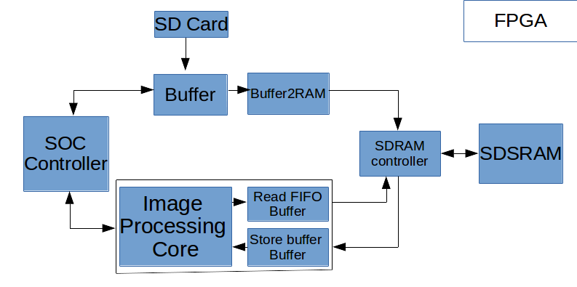

* Need note...

## 1.2 IPC flowchart

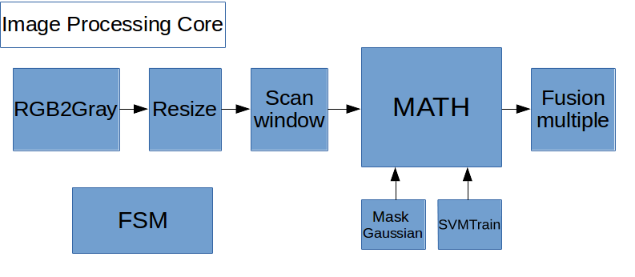

* Need note...

## 1.3 MATH flowchart

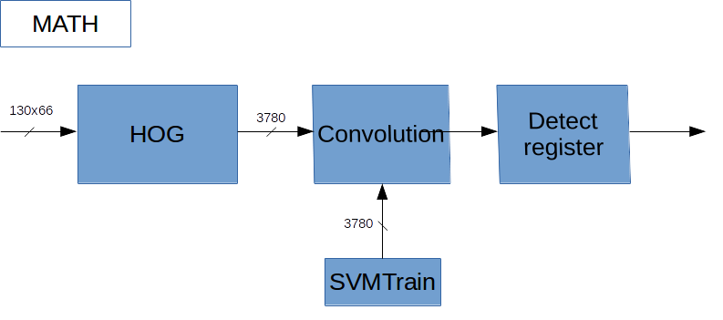

* Need note...

## 1.4. HOG flowchart

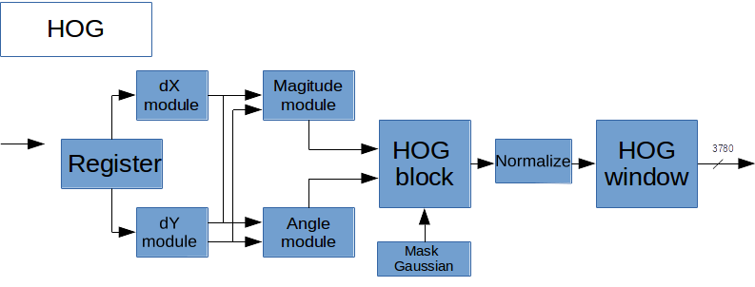

* Need note...

# **2. Detail architecture**

## 2.1. Introduction

* After read some documents, I find out the best architecture
* Source document: [An Energy-efficient Hardware Implementation of HOG-based.pdf](https://drive.google.com/file/d/0BxghKvvmdklCRjB6OEdsRE0tSDg/view?usp=sharing)

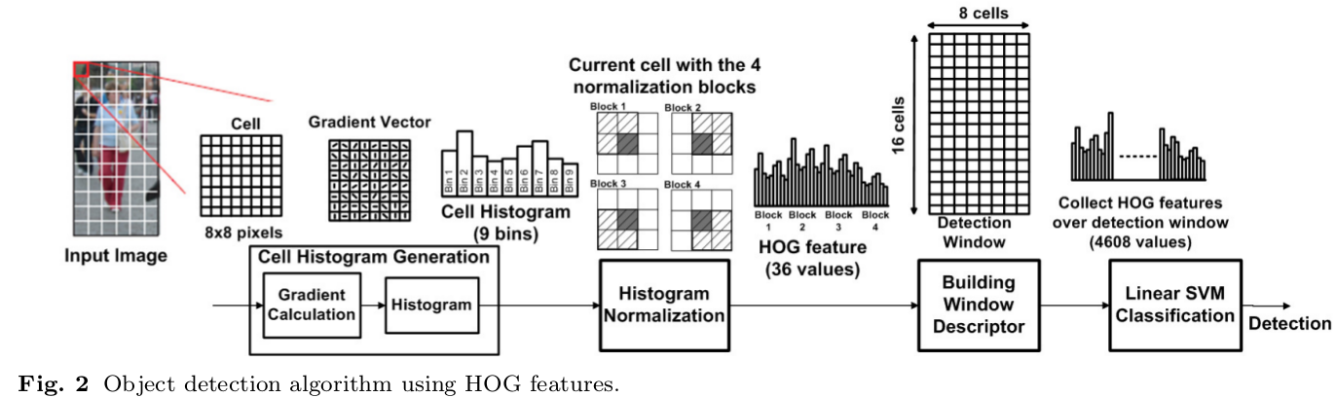

## 2.2. Calculate HOG

* Input is each cell (8x8 pixel)
* Normalization use L2-norm
* Use fixed-point float to save values of HOG

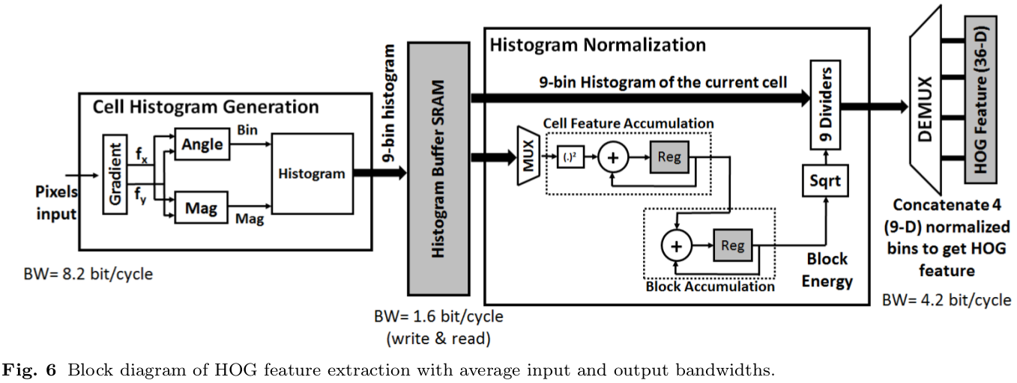

## 

## 2.3. SVM classification

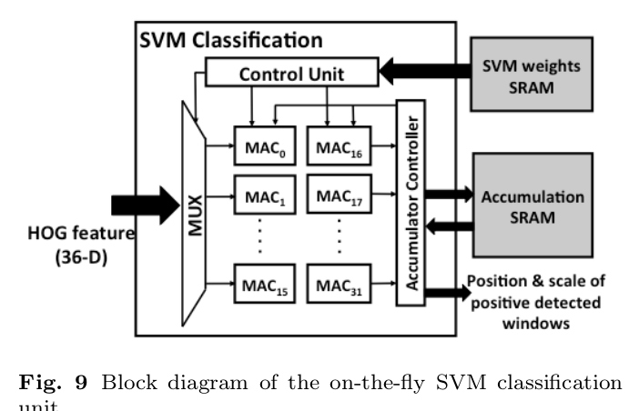

## 

## 

# **3. Conclution**

* Kiến trúc này sẽ scan từ khung ảnh 130x66 từ hình ảnh gốc 640x480. Sau đó bộ cơ bản nhất sẽ là scan từng cell 8x8 pixels.
* Vì vậy cần edit code C để có thể hình dung được how to work